**SYNONYMS**

**Dpln z ucebnic personal characted English plus 2 a 3**

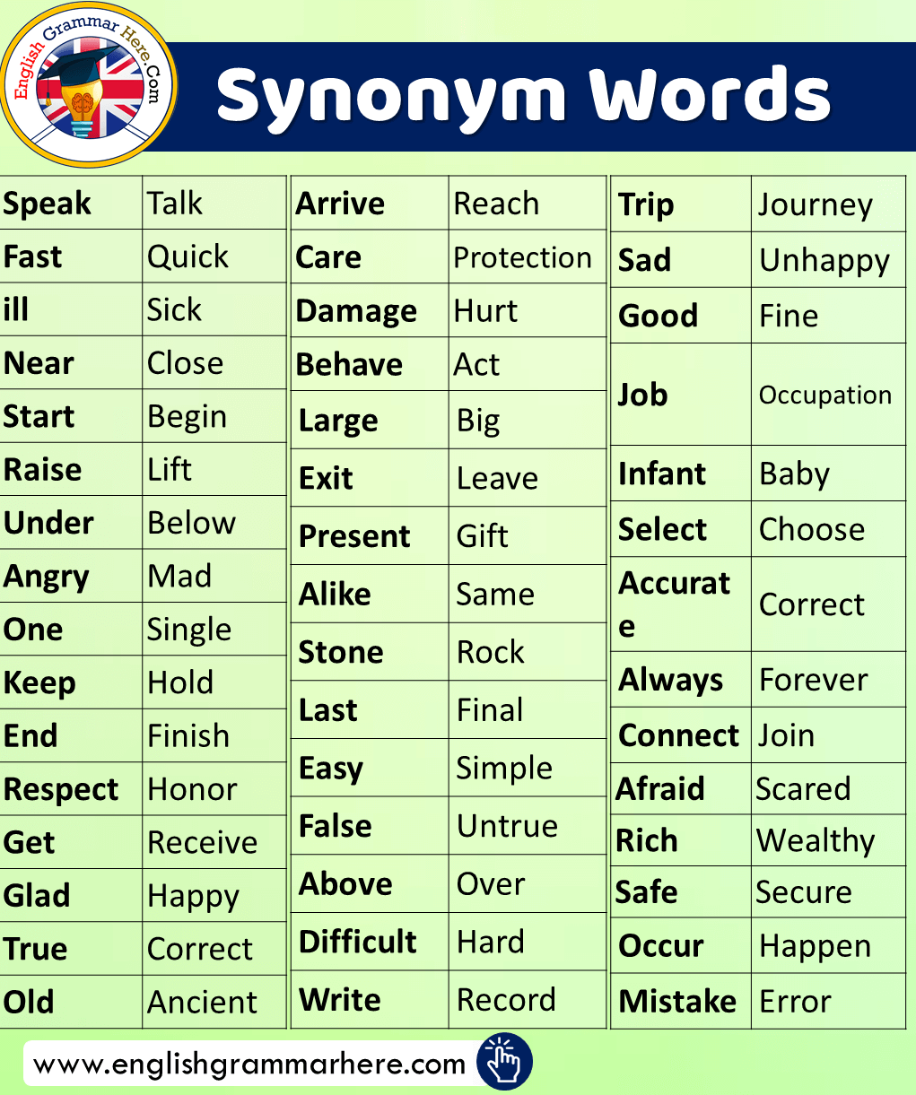

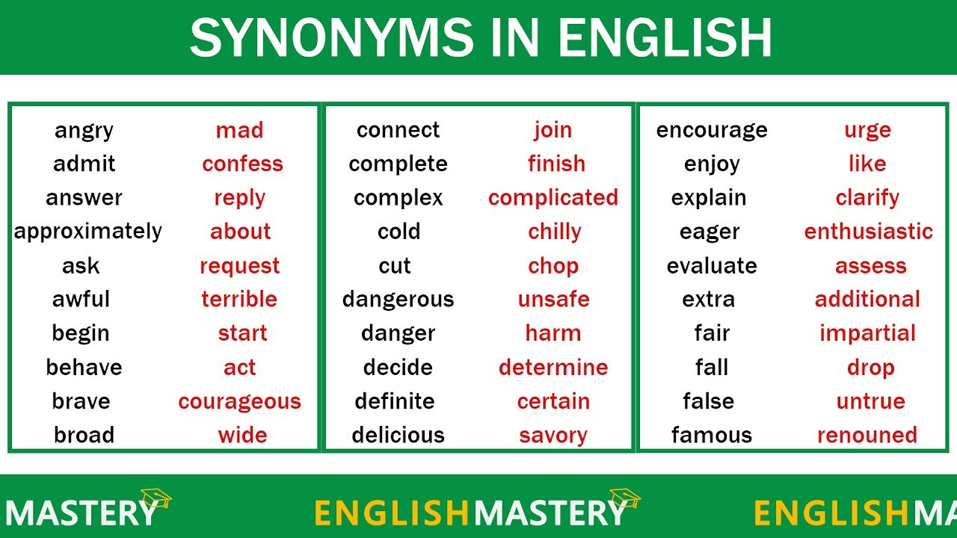

good looking – handsome untidy – messy wealthy – rich,

cry – shout – scream – yell look – stare – gaze – glance – glimpse

**ANTONYMS**

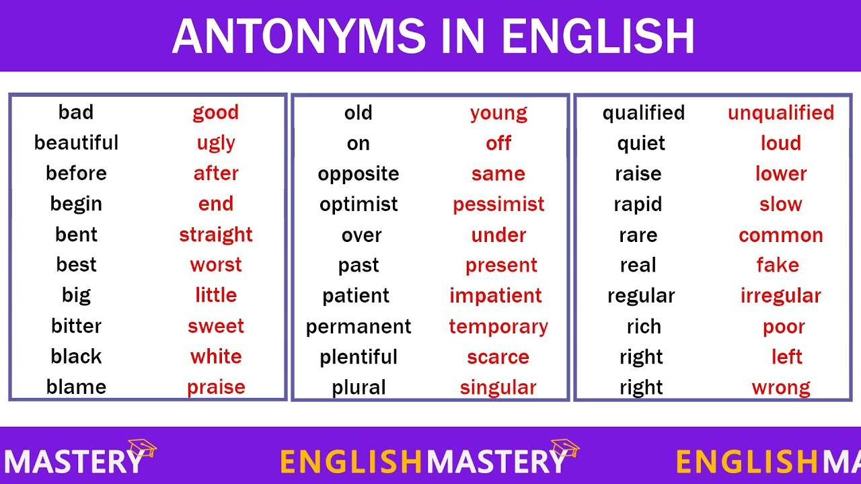

high – low tall – short poor – rich

thin – thick clever – stupid open – close

departure – arrival mean – generous disgusting – delicious

refuse – accept

**Exercises 1**

1. to begin → usually → terrible → missing → great → rubbish → couch → almost → to answer → away →

Choose the best synonym for each word.

absent, awful, fantastic, garbage, lost nearly, normally, sofa, to reply, to start

**Exercises 2**

Find synonym for a word:

**Kind** nice, wild funny, best

**Fast** quick, kind, heavy, small

**Skinny** small, little, thin, strong

**Angry** happy, mad, tired, sad

**Cheap** poor, costly, pricey, inexensive

**Nervous** short, direct, crazy, anxious

**Many** a few, some, none, a lot

**Produce** buy, make, sell, find

**Mistake** mark, error, game, job

•   Mark

• •   Error

• •   Game

•   Job

**Occupation**

•   Job

• •   Man

• •   See

•   Do

**Entire**

•   Half

• •   Whole

• •   Most

•   Part

**Apart**

•   Joined

• •   Separate

• •   Moving

•   Together

**Steady**

•   Fast

• •   Certain

• •   Complete

•   Consistent

**Grateful**

•   Supportive

• •   Thankful

• •   Healthy

•   Kind

**Maybe**

•   Doubtfully

• •   Surely

• •   Perhaps

•   Definitely

**Warning**

•   Attention

• •   Emergency

• •   Victim

•   Caution

**Decline**

•   Mountain

• •   Discipline

• •   Hill

•   Decrease

Kľúč: 2. nice, quick, thin, mad, inexpensive, anxious, a lot,